Notice (Wales) re 3rd International Maths Camp March 2023.

ATTENTION high school students

International Online Maths Camps

FUN, THINKING, FRIENDSHIP

Join with students and mathematicians from five different countries for some interesting mathematics and cultural exchanges.

The camps will be run online using ZOOM. Students will attend two three-hour sessions, both on Saturdays. Each session consists of two Maths Worlds. The Maths Worlds are based upon modern maths ideas and they are suitable for any keen high school student. Students are encouraged to interact in the Worlds with students from different countries.

School students aged 15+ are invited to register. Registered students are expected to attend both sessions. This is important for the planning and continuity across sessions. There is no cost, but numbers are limited.

All sessions are conducted in English, although some local translation may occur.

Informal pre-registration is required through your teacher or directly with FMSPW. Formal registration will involve completion of a parental consent form.

The schedule:

Saturday March 18 (European and USA students):
09:00 USA, 16:00 GERMANY, 15:00 – 18:00 WALES

Saturday March 25 (European and Asian students):
9:00 – 12:00 Wales, 10:00 GERMANY, 18:00 JAPAN, 18:30 Australia (NT),

This online Maths Camp is a response to Covid-19 and builds upon previous live Maths Camps that began in 2009. The Camp is organised and led by mathematicians and maths teachers in 5 countries, each with significant national and international experience in maths enrichment. All mathematicians involved are formally approved to work with children by their local authorities.

Wales Coordinator – Dr Sofya Lyakhova, Associate Professor of Mathematics

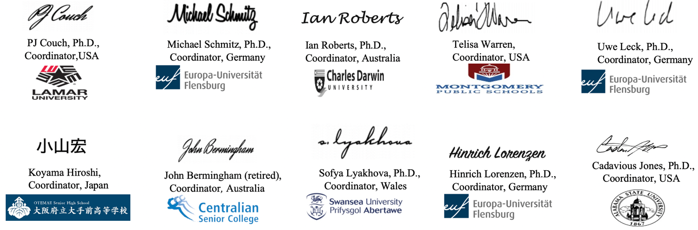

Overview of online Maths Camp - a student perspective.

FUN, THINKING, FRIENDSHIP

The mathematical activities are about co-operation, not competition. There are no prizes, just personal satisfaction.

For each student there are two 3-hour live online sessions. Each session consists of two Maths Worlds, developed by mathematicians from different countries. Each World is about mathematical problem solving and thinking. The topics are accessible to school students, but they are not part of the school curriculum. There is a short break between Worlds on the same day.

The Worlds require students to work together in groups. Sometime this will be in one large group, and other times in small groups in Zoom breakout rooms. Students are required to explain their ideas to others. The common language is English, but students may freely talk in their native language as well. Ideas can be demonstrated with minimal talking if desired. Every student will need to be able to show their written work, or to demonstrate their ideas using their camera. This will help to deal with language issues.

Please speak slowly and clearly to one another and give time for everyone to process your words, and especially those from non-English speaking backgrounds. Ensure that you sign-in to the sessions with a simple single name in English script that others can read and pronounce.

The pairing of countries in each session is different, so every student will work with students from at least two other countries. It is encouraged to chat and share some things about your life and country.

Mathematics is a very isolated pursuit and a very social pursuit. Most mathematicians work with colleagues because it is FUN and because maths is HARD, and a creative group is much more productive than isolated individuals. So we need lots of quiet time and lots of social interaction.

Each of the mathematicians work together with English as the most commonly used language. The mathematicians and students working languages include English, German, Japanese, Russian and Welsh. Most of the mathematicians do mathematical research, creating new mathematical ideas and results. We all work with school students in our own countries, and try to share the excitement of thinking and doing mathematics, and to develop the next generation.

