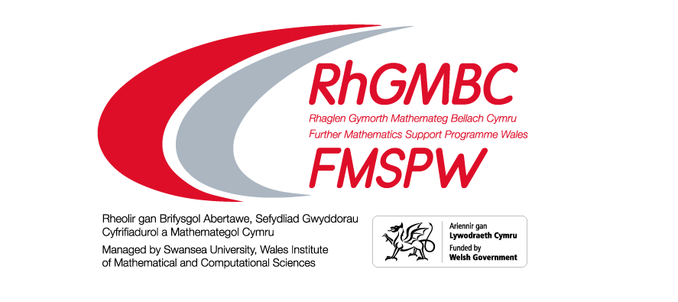
Mathematical Discovery . . .
One day conference for Yr 12 Mathematics students
17th January 2023 – Aberystwyth University
09:15am – 14:30pm

Places will be allocated on a first come first served basis. Please return this form by 11th January 2023.
The more the merrier but where possible please ensure an equal spilt between male and female students.
We wish to bring staff and students to the ‘Mathematical Discovery’ Conference
Location | No. staff | No. students
Aberystwyth University

Name of
school/college
Contact
Email
Address
Post Code
Telephone

Signed: |  | Date:

An acknowledge with be sent on receipt of this application

