DATGANIAD NEWYDDION I YSGOLION A CHOLEGAU, Awst 2023
Dathlu Mathemateg a Mathemateg Bellach Safon Uwch yng Nghymru
Mae Cymru'n dathlu blwyddyn arall o lwyddiant gyda niferoedd myfyrwyr Mathemateg a Mathemateg Bellach Safon Uwch yn parhau i fod yn uchel yn 2023. Yn ôl y Cyd-gyngor Cymwysterau (2022) parha i Mathemateg Safon Uwch fod y Safon Uwch mwyaf poblogaidd yng Nghymru a chynrychiola y nifer o gymhwysterau Mathemateg a Mathemateg Bellach UG cynnydd da ar gofnodion blwyddyn diwethaf:
- Dyfarnwyd cymhwyster Mathemateg Safon Uwch i 3630 myfyriwr a dyfarnwyd cymhwyster Mathemateg Bellach Safon Uwch i 583 myfyriwr yn 2023;
- Enillodd 4602 myfyriwr gymhwyster Mathemateg UG sy’n gynnydd o 17% ers y llynedd ac enillodd 570 myfyriwr gymhwyster Mathemateg Bellach UG sy’n gynnydd o 64% ers y llynedd.

Graff 1. Canrannau myfyrwyr Mathemateg Safon Uwch sy'n cymryd Mathemateg Bellach Safon Uwch yng Nghymru a Lloegr ers 2003 (https://www.jcq.org.uk/examination-results/)

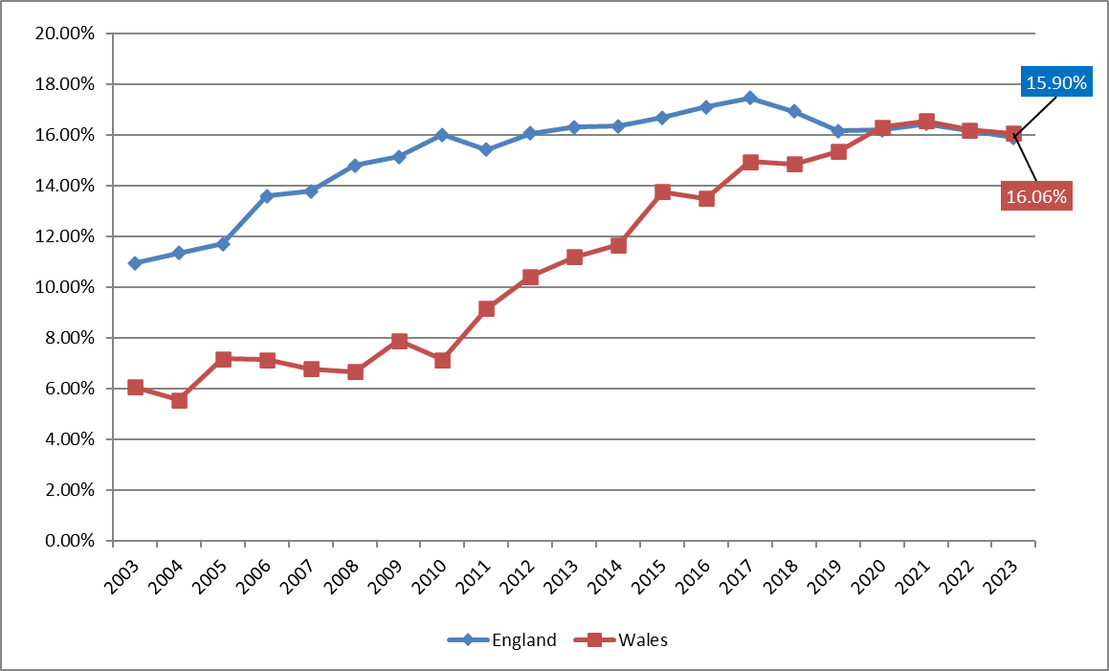
Cymru
Lloegr

Dyfarnwyd y graddau UG a Safon Uwch canlynol yng Nghymru yn 2023:
- Enillodd 28.7% o fyfyrwyr A* ac enillodd 51.8% A*/A ym Mathemateg Safon Uwch;
- Enillodd 44.3% o fyfyrwyr A* ac enillodd 64.7% A*/A ym Mathemateg Bellach Safon Uwch;
- Enillodd 36.9% a 63.9% o fyfyrwyr A ym Mathemateg a Mathemateg Bellach lefel UG yn ôl eu trefn.

Mae cymwysterau Mathemateg Bellach yn galluogi myfyrwyr i gyfoethogi eu profiad Mathemateg ac adeiladu sylfaen fwy cadarn ar gyfer dilyn gyrfaoedd mewn Gwyddoniaeth, Technoleg, Economeg, Gwyddor Actiwaraidd a Chyllid. Parha’r cymwysterau i fod yn ofynnol neu'n ddeniadol ar gyfer cael mynediad i rai rhaglenni gradd yn y DU ac mae rhai prifysgolion yn ei gwneud yn ofynnol i fyfyrwyr sefyll arholiadau ychwanegol ac uwch mewn mathemateg.

Menter yw Rhaglen Gymorth Mathemateg Bellach Cymru (RhGMBC) a ariennir gan Lywodraeth Cymru a’i rheoli gan yr Adran Mathemateg ym Mhrifysgol Abertawe, WIMCS. Lansiwyd y rhaglen yn 2010 ac mae’n cynnig cyrsiau datblygu proffesiynol athrawon, adnoddau dysgu ar-lein dwyieithog, rhaglenni cyfoethogi ar gyfer myfyrwyr CA4 a Safon Uwch yn ogystal â hyfforddiant Mathemateg Bellach byw ar-lein a chefnogaeth ychwanegol ar gyfer profion prifysgolion.

Dywedodd James Johnson o Ysgol Brynhyfryd sy’n astudio Mathemateg Bellach gyda’r RhGMBC ac a enillodd A mewn Mathemateg Bellach UG “Mae Astudio Mathemateg Bellach wedi bod yn hwyl, heriol a gwerth chweil dros y flwyddyn ddiwethaf. Mae'r tiwtoriaid wedi rhoi digon o gefnogaeth i mi ac roedd llawer o adnoddau ar gael i'n cynorthwyo yn ystod y flwyddyn. Nid oedd Mathemateg Bellach ar gael yn fy ysgol felly heb RhGMBC ni fyddwn wedi gallu ei gymryd.”

Dywedodd rhiant myfyriwr o Ysgol Gyfun Tregŵyr a enillodd A* mewn Mathemateg a Mathemateg Bellach ac sydd wedi’i derbyn i astudio Cyfrifiadureg ym Mhrifysgol St Andrews: “Mae Astudio Mathemateg Bellach drwy’r RhGMBC wedi bod yn rhaglen anhygoel, ni allaf argymell eich tîm ddigon, mae'r gefnogaeth rydych chi wedi'i rhoi i Ryan wedi bod yn wych. Rydym mor ddiolchgar, heb eich rhaglen ni fyddai Ryan yn mynd i Brifysgol lefel uchaf.”

Dywedodd Dr Sofya Lyakhova, arweinydd rhaglen RhGMBC: “Diolch i gyllid gan Lywodraeth Cymru, drwy RhGMBC mae cymorth ar gael i bob ysgol a choleg a ariennir gan y wladwriaeth i feithrin gallu i ganiatáu i fwy o fyfyrwyr astudio mathemateg ôl-16. Mae’n wych gweld bod nifer y myfyrwyr sy’n cwblhau cymwysterau Mathemateg Bellach yn parhau’n uchel.”

Gwahoddir i bob ysgol uwchradd a choleg yng Nghymru a ariennir gan y wladwriaeth i gofrestri gyda’r Rhaglen trwy ddilyn http://mathsbellach.cymru/ ac yna “Cofrestrwch”, a dangos ei diddordeb mewn cymorth hyfforddiant trwy gysylltu fmspwales@swansea.ac.uk.

Nodiadau i olygyddion
- Ariennir y RhGMBC gan Lywodraeth Cymru a chaiff ei rheoli gan Brifysgol Abertawe, y Sefydliad Gwyddorau Cyfrifiadurol a Mathemategol Cymru (WIMCS).
- Gellir cael rhagor o wybodaeth ynglŷn â Rhaglen Gymorth Mathemateg Bellach Cymru yma: http://mathsbellach.cymru/. Ar gyfer astudiaethau achos gan fyfyrwyr, rhieni ac ysgolion ewch i https://furthermaths.wales/cy/cy-students/cy-case-studies/
- Partneriaeth gydweithredol yw’r Sefydliad Gwyddorau Cyfrifiadurol a Mathemategol Cymru (WIMCS) rhwng prifysgolion Aberystwyth, Bangor, Caerdydd, De Cymru ac Abertawe. Sefydlwyd gan Lywodraeth Cymru drwy Gyngor Cyllido Addysg Uwch Cymru. Nod WIMCS yw gwella statws Mathemateg a Chyfrifiadureg yng Nghymru, er mwyn meithrin cysylltiadau â diwydiant, masnach a busnes, er mwyn cynhyrchu cyllid ymchwil sylweddol a darparu fforwm ar gyfer addysg ac ymwybyddiaeth y cyhoedd o'r Gwyddorau Mathemategol.
- Mae'r holl ffigyrau yn yr adroddiad yn seiliedig ar y data a gymerwyd o www.jcq.org.uk
- Am ragor o wybodaeth cysylltwch â Gweinyddwr RhGMB Cymru trwy e-bost rhgmbcymru@swansea.ac.uk

NEWS RELEASE TO SCHOOLS AND COLLEGES, August 2023
Celebrating A-level Mathematics and Further Mathematics in Wales
Wales is celebrating another year of success with the numbers of A-level Mathematics and Further Mathematics students remaining high in 2023. According to the Joint Council for Qualifications (2022) A-level Mathematics remains the most popular A level in Wales and the number of AS Mathematics and Further Mathematics qualifications represent a good increase on last year entries:
- 3630 students were awarded an A-level Mathematics qualification and 583 students were awarded an A-level Further Mathematics qualification in 2023;
- 4602 students achieved an AS Mathematics qualification which is a 17% increase from last year, and 570 students achieved an AS Further Mathematics qualification which a 64% increase from last year.

Graph 1. Percentages of A-level Mathematics students taking A-level Further Mathematics in England and Wales since 2003 (https://www.jcq.org.uk/examination-results/)

The following AS and A-level grades were awarded in Wales in 2023:
- 28.7% of students achieved A* and 51.8% achieved A*/A in A-level Mathematics;
- 44.3% of students achieved A* and 64.7% achieved A*/A in A-level Further Mathematics;
- 36.9% and 63.9% of students achieved A in AS-level Mathematics and Further Mathematics respectively.

Further Mathematics qualifications allow students to enrich their Mathematics experience and build a more solid foundation for pursuing careers in Science, Technology, Economics, Actuarial Science and Finance. The qualifications remain required or preferred for entering some degree programmes in the UK and a few universities require students to take additional and more advanced examinations in mathematics.

The Further Mathematics Support Programme (FMSPW) is a Welsh Government funded initiative managed by the Mathematics Department at Swansea University, WIMCS. The programme was launched in 2010 and offers teacher professional development courses, online bilingual learning resources, enrichment programmes for KS4 and A-level students as well as live online Further Mathematics tuition and additional university tests support.

James Johnson from Ysgol Brynhyfryd who is studying Further Mathematics with the FMSPW and who achieved A in AS Further Mathematics said “Studying Further Maths has been a fun, challenging and rewarding experience over the last year. The tutors have provided me plenty of support and there were lots of resources available to assist us during the year. Further Maths was not available at my school so without the FMSPW I would not of been able to take it.”

A parent of a student from Gowerton Comprehensive School who achieved A* in both Mathematics and Further Mathematics and has been accepted to study Computer Science in St Andrews University commented: “Studying Further Maths through the FMSPW has been an amazing programme, I can’t recommend your team enough, the support you’ve given Ryan has been fantastic. We are so grateful, without your programme Ryan wouldn’t be going to a top level University.”

Dr Sofya Lyakhova, FMSPW programme leader, said: “Thanks to the funding from the Welsh Government, through FMSPW support is available to all state-funded schools and colleges in building capacity to allow more students to study mathematics post-16. It is wonderful to see that the number of students completing Further Mathematics qualifications remains high.”

All state-funded secondary schools and colleges in Wales are invited to register with the Programme following https://furthermaths.wales/ and clicking “Register”, and express their interest in tuition assistance by contacting fmspwales@swansea.ac.uk.

Notes for Editors
- The FMSPW is funded by the Welsh Government and is managed by Swansea University, Wales Institute of Mathematical and Computational Sciences (WIMCS).
- More information regarding the Further Maths Support Programme Wales can be found at: http://furthermaths.wales/. For case studies from students, parents and schools please visit http://furthermaths.wales/students/studentcs/
- The Wales Institute of Mathematical and Computational Sciences (WIMCS) is a collaborative partnership between the universities of Aberystwyth, Bangor, Cardiff, South Wales and Swansea. It has been set up by the Welsh Government through the Higher Education Funding Council for Wales. WIMCS aims to enhance the standing of Mathematics and Computation in Wales, to foster links with industry, commerce and business, to generate substantial research funding and to provide a forum for education and public awareness of the Mathematical Sciences.
- All the figures in the report are based on the data taken from www.jcq.org.uk
- For more information please contact the FMSP Wales Administrator by email fmspwales@swansea.ac.uk

