Innovation and Creativity
in Mathematics Teaching IV

One-day conference for Mathematics teachers
14th July 2023 – Swansea University
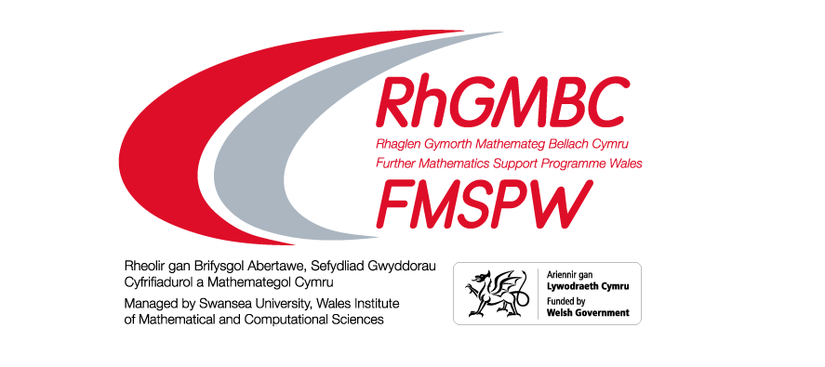

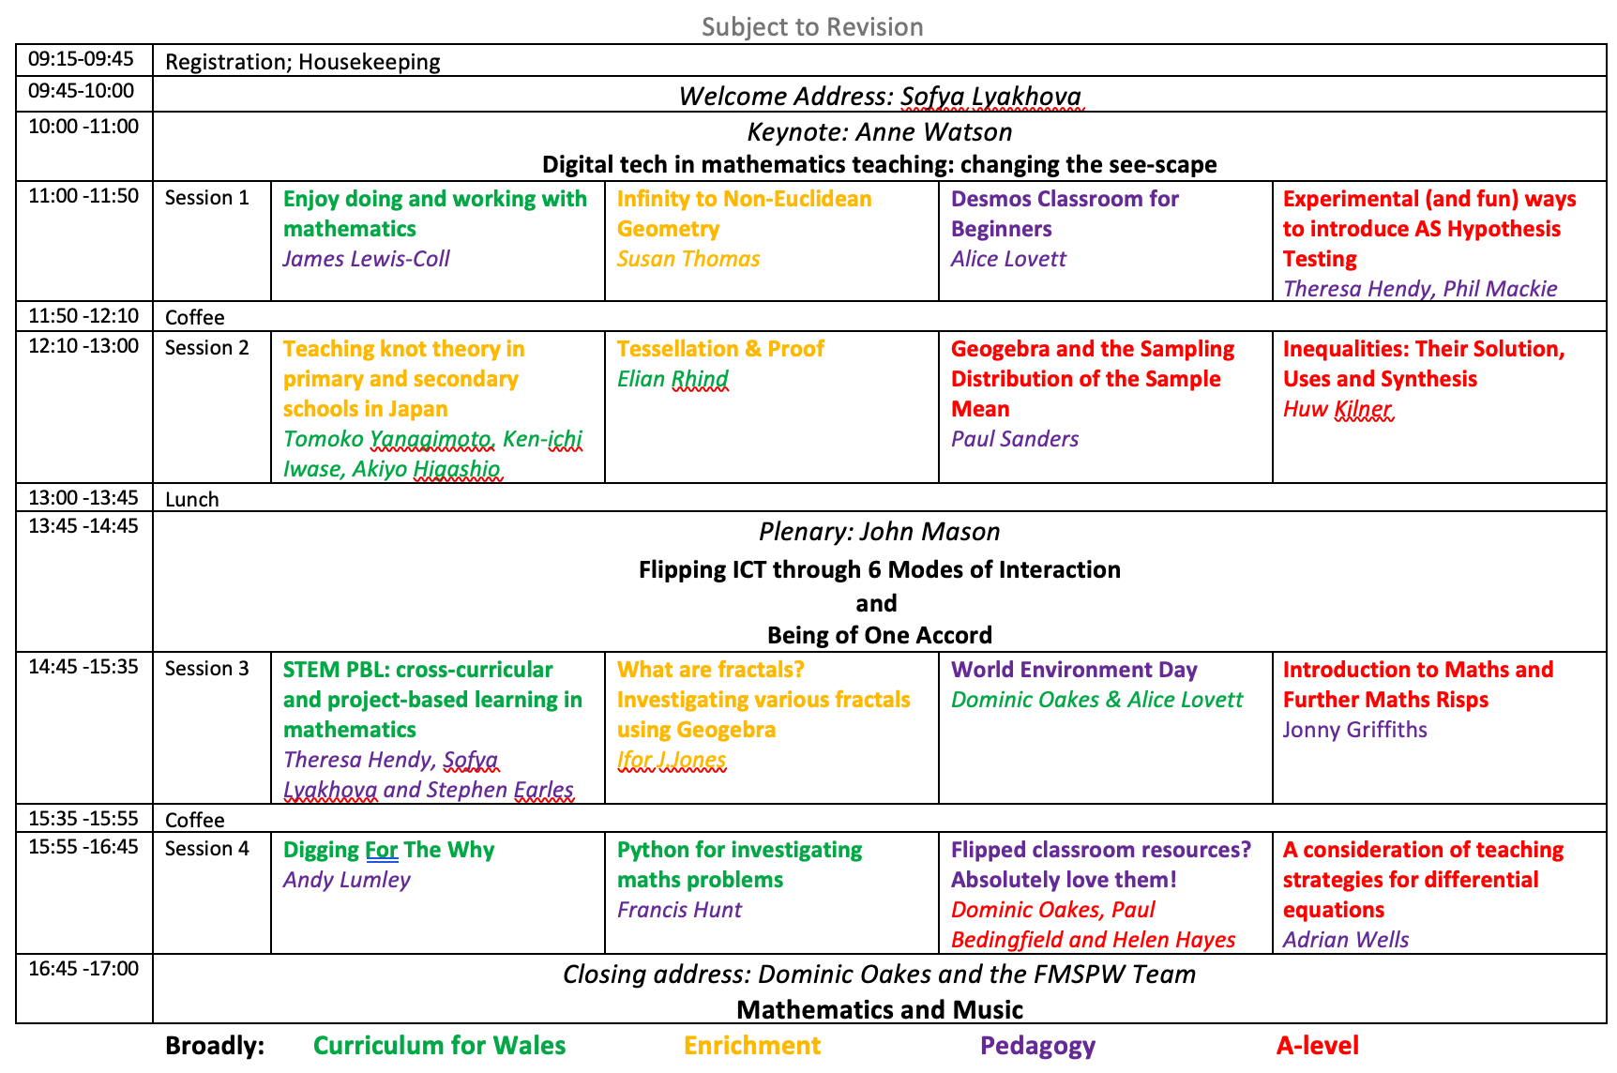
Keynote

Digital tech in mathematics teaching: changing the see-scape
Professor Anne Watson
(University of Oxford)

Emeritus Professor Anne Watson has two mathematics degrees and taught mathematics in challenging schools before undertaking teacher education and mathematics education research at the University of Oxford, where she had gained a doctorate that addressed informal mathematics assessment. She advised on the mathematics national curriculum in England and also in Wales. She works with educators and researchers worldwide on mathematics curriculum, task design and pedagogy. She has written and edited numerous books, articles and research papers including ‘Key Ideas in Teaching Mathematics’ with Keith Jones and Dave Pratt (Oxford University Press), ‘Key Understandings in Mathematics’ with Terezinha Nunes and Peter Bryant (Nuffield Foundation) and ‘Care in Mathematics Education’ (Palgrave Macmillan).
I will explore some connections between mathematics topics throughout school that, given easily available digital technology, radically reconstruct the ways in which they can be learnt and the traditional ordering of the curriculum. The audience will have to do some work too.
Key words: | Number; functions; spatial representations; digital power; CfW
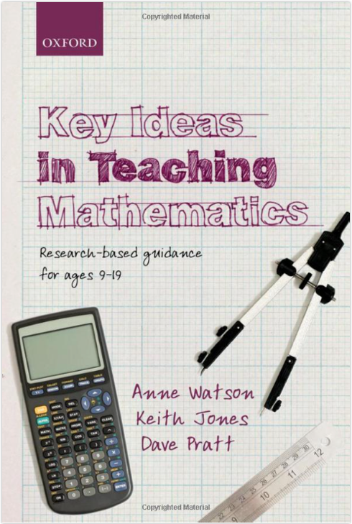

Session 1

Enjoy doing and working with mathematics
James Lewis-Coll (Central South Consortium (CSC))
James worked in the Scottish, English and now in the Welsh education system. In a previous school he developed and ran PGCE courses for secondary mathematics and for primary students. He has worked for CSC as a mathematics specialist for about 8 years supporting schools with developments in mathematics. James says, “I enjoy attending mathematics conferences!’

Having access to a wide range of curriculum tasks will support the development of using mathematics since “looking back may be the most important part of problem solving” (Wilson, Fernandez, Hadaway).
This session will consider a range of tasks that will challenge and support the development of students’ mathematical skills via problem solving and contextual work. These tasks will be suitable for students across ks3, ks4 and ks5 linking to real-life contexts, practical applications and mathematical problems.
The activities will include links to art through considering the question, “How long is a railway line?” and for those of a more musical disposition, “How do fruit yoyos link to vinyl LPs?”. Further tasks, among others, will be to investigate whether it is possible to comfortably fit the world’s population into a well-known Scottish landmark and then to travel south to Haworth in Yorkshire to appreciate a beautiful sculpture with money.
Key words: | Applying, modelling, contexts, mathematical thinking, mathematics, modelling, KS3, KS4, KS5, practical, applications, GCSE, A-level, cross-curricular, real-life, estimation. CfW: Cross-curricular skills
Participants should bring: | Paper and pens / pencils, calculator

Anfeidredd / Infinity to Non-Euclidean Geometry
Susan Thomas (FMSPW)
Head of Maths at Llanhari (Jan 1992-Sept’96), at Ystalyfera (1996-2010). FMSP Wales since 2011. FMSPW SoW Team.
Infinity is something to which we are introduced in our mathematics classes, and later we learn that infinity can also be used in physics, philosophy, social sciences, etc. The intersection of infinity with geometry can be seen by looking at projective geometry, with parallel lines intersecting ‘at infinity’. It could be said that projective geometry involves the taming of infinity.

This session looks at Infinity and moves via Leonardo da Vinci, Escher, Penrose and Coxeter to Non-Euclidean Geometry in a sometimes strange voyage of discovery.
Key words: | Infinity, art, non-Euclidean geometry, enrichment
Participants should bring:

Desmos Classroom for Beginners
Alice Lovett (FMSPW)
FMSPW South East Wales Area Coordinator.
Qualified as a Mathematics teacher in 2006. Teaching in a range of schools with a variety of sixth forms. Previous roles include key stage 3 coordinator, key stage 5 coordinator and Head of Mathematics: as well as qualifying as a specialist leader in education. Interests include Leicester Tigers, Orienteering, Desmos and teaching the same thing in as many ways as possible.
Desmos Classroom (DC) is a fantastic online resource. At FMSPW amongst many varied uses of DC, we developed a course for Additional Mathematics which has been successfully used as the basis for taking many students through the course successfully.

Seeing is believing and the interactive nature of DC activities can accelerate student understanding of a range of mathematical concepts and techniques.

In this session you will learn how to set up a DC course, how to make engaging activities for students in KS3-5 and how to use DC in the classroom and for homework.
Key words: | Dynamic software, KS2-5, AfL, ICT, interactive, engagement, depth, problem-solving, play, CfW: use digital technologies creatively
Participants should bring: | Laptop

Experimental (and fun) ways to introduce AS Hypothesis Testing
Philip Mackie and Theresa Hendy (Gower College Swansea)
Phil and Theresa have both been teaching A level mathematics for more than twenty years in Further Education. Phil previously worked in a marine laboratory doing mathematical modelling and statistical analysis of oceanic carbon fluxes and Theresa taught maths in a secondary school.
A practical, hands-on, data collecting session where we will look at introducing hypothesis testing with the Binomial Distribution using a variety of statistical experiments; all of which can easily be replicated in the classroom. We will also look at how GeoGebra can support the understanding of decision making when drawing conclusions.
Key words: | AS statistics, hypothesis testing, Binomial Distribution
Participants should bring: | Classwiz calculator or similar (with probability distributions)

Session 2

Teaching knot theory in primary and secondary schools in Japan
Tomoko Yanagimoto, Ken-ichi Iwase, Akiyo Higashio (Osaka Kyoiku University & Osaka Electro-communication University)
Professor Tomoko Yanagimoto, Professor Ken-ichi Iwase, and Dr. Akiyo Higashio are mathematics educators who lead a working group on teaching knot theory in schools in Osaka prefecture, Japan. The group was formed in 2004 when Hirokazu Okamori, a researcher in mathematics education, and Akio Kawauchi, at the time a leading mathematician on knot theory in Japan, met to discuss the implications of a new mathematical theory for school mathematics teaching. Professor Kawauchi was also Tomoko Yanagimoto's PhD supervisor. Tomoko, Ken-ichi, and Akiyo have extensive experience teaching mathematics in both primary and secondary schools, teaching undergraduate students, and working with teachers. Professor Yanagimoto also served as a headteacher in a primary school while being a full-time researcher and a professor of mathematics education. Their research focuses solely on knot theory and school curriculum.
Mathematics teachers and educators always seek to develop teaching content that goes beyond traditional school mathematics in order to cultivate children's understanding of and interest in the subject. Knot theory presented itself as one such opportunity when a mathematics education researcher and a mathematician met and formed a vision for this in 2004. Soon after, they formed a study group of mathematics researchers, mathematicians, and elementary, junior, and senior high school teachers to work on this. The group initially began by learning the basics of knot theory and delving into its educational implications. After nearly two decades, several generations of teachers became enthusiasts of knot theory, and numerous teaching and learning materials were developed and tested in primary and secondary classrooms. We are core members of the study group and invite participants to join this hands-on workshop to learn some knot theory as part of school mathematics, and to hear about the successes and challenges of teaching it to students.
Key words: | KS3 & KS4, peer work, cross-curricular, enrichment, curriculum
Participants should bring: | Practical manipulatives to try knot theory will be provided

Tessellations and Proof
Elian Rhind (Further Mathematics Support Programme Wales)
Studied Mathematics as both an undergraduate and postgraduate student at Swansea University, completing a PhD in Mathematics in 2018. In the same year, was a fixed-term tutor for the Mathematics Department at Swansea University. Worked with FMSPW as a student helper for many years but joined the programme working in fuller capacity in 2018.
The tessellation of shapes is found naturally as well as in man-made creations across various situations. Here, we look at the tessellations of geometrical objects, namely regular (using one polygon) and semi-regular (using at least two polygons) tessellations. This work ties nicely to geometry-based work at GCSE, with room to abstract ideas as algebra is introduced (it can be proved algebraically that only three regular tessellations are possible). If time allows, there is scope to abstract ideas of semi-regular tessellations as well as three-dimensional polyhedrons.

This year, I have presented this work to key stage 3 and 4 students, adapting the material to suit the audience. In these sessions I hand out polygonal shapes for the students to experiment with so that they can find the possible tessellations first-hand (this can also be tried out at this conference). As well as seeing the mathematics justifying the tessellations working, I have found that students benefit from seeing the idea of tessellations literally clicking together in front of them. I hope to present a similar session in this conference (bilingually in both Welsh and English) and show how this can be a nice demonstration of ideas of polygonal geometry.

Key words: | Geometry, Algebra, Abstraction, Proof
Participants should bring: | Pen/pencil

Geogebra and the Sampling Distribution of the Sample Mean
Paul Sanders (FMSPW)
After 35 years teaching Maths in 11-18 schools in Lancashire and Monmouthshire, I am now in my tenth year working with FMSPW and have been actively involved with the development of the professional learning programme and many of the video resources for A level Maths and Further Maths courses.
For the statistician, the real importance of the Normal distribution is the fact that if random samples of size n are taken from a population with mean μ and variance σ² then the sample mean, $\overline{X}$, will have a probability (or sampling) distribution
- of $N\left(μ , \frac{σ^{2}}{n}\right)$ if the original distribution is itself normal.
- approximately $N\left(μ , \frac{σ^{2}}{n}\right)$ if n ≥ 30 .
The first of these results is required by the M4 specification of the WJEC syllabus, the second of these results is the “Central Limit Theorem”.

Proofs of either of these results is beyond the scope of the A level students, however the importance of the results demands a degree of justification.

During the presentation a Geogebra applet will be developed to motivate the first of the two results and relatively minor adaptations of the applet will enable the Central Limit theorem to be motivated as well.

Participants with reasonable familiarity of the basic features of Geogebra are invited to bring their devices to construct the applet in real time. It is hoped that others will also consider attending to view one way in which Geogebra can be used in the classroom to motivate and partially justify complex concepts.
Key words: | Normal Distribution, Sampling Distribution of sample mean, Central Limit Theorem, Geogebra, KS5
Participants should bring: | Laptop with Classic 5 or Classic 6 Geogebra installed.

Inequalities: Their Solution, Uses and Synthesis
Huw Kilner (Cardiff Sixth Form College)
I was formerly an Electronics Engineer and I worked in the Defence and Seismology sectors. I then taught Mathematics in a comprehensive school for over 30 years. For the last 11 years I have taught the STEP and MAT classes at Cardiff Sixth Form College and I am the author of a book that is entirely about STEP questions and their solutions. My current interests concern the development of mathematical thinking skills in this context.
My aims are to respond positively to an issue raised by the Chief Examiner for STEP and to provide some material that I hope will be of immediate use within the classroom.

Using past examination questions, the journey will take us from the simplest inequalities, through methods of solution and the application of inequalities, to the synthesis and proof of the AM-GM inequality and the Cauchy-Schwarz inequality. Buckle up for a high-speed ride!
Key words: | Visualisation, Estimation, Application. STEP, MAT, KS5

Plenary

Flipping ICT through 6 Modes of Interaction
and
Being of One Accord
Professor John Mason
(Open University and University of Oxford)

Retired for some 14 years after 40 years at the Open University writing materials to support the teaching of mathematics in all phases, John continues to engage in mathematical explorations generated by pedagogical issues.
Participants will be invited to engage in some mathematical tasks to do with chords of (graphs of) functions, leading to a discussion of different modes of interaction between learner, mathematics, and teacher. This in turn will raise questions about different ways to use mathematical software to ‘flip’ a classroom. The core role of attention, both mathematical and social will anchor the discussion.
Key words: | Flipping, Classroom Interactions

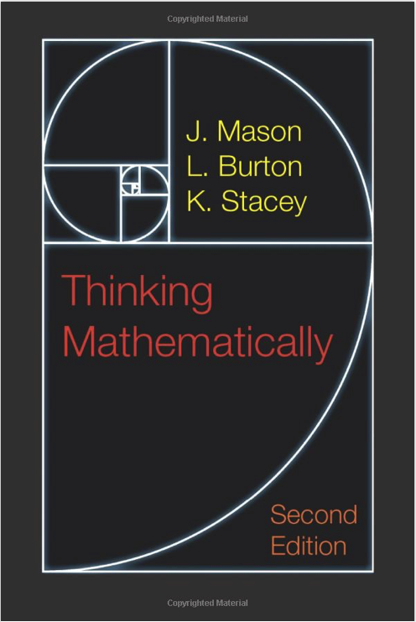
Session 3

STEM PBL: Cross-curricular and project-based learning in mathematics
Theresa Hendy, Sofya Lyakhova and Stephen Earles (FMSPW)
Theresa’s teaching career has spanned more than 20 years. She initially taught mathematics in a secondary school and continued in Further Education including being a Head of Department and Curriculum Leader for maths and science as well as teaching basic skills and access to HE courses for adults. Theresa joined the FMSPW team in 2010 initially as a tutor and recently was appointed as an Area Coordinator for South & Mid-Wales and Professional Learning lead. Theresa holds an MA in Education. She is passionate about encouraging peer-to-peer dialogue in a traditional classroom and worked as a teacher-researcher for the National Network for Excellence in Mathematics in Wales in 2016.
Sofya Lyakhova is an associate professor of mathematics at Swansea University and FMSPW Programme Leader. She has worked on a range of research projects initially in pure mathematics, and later in mathematics education and technology-enhanced learning within the Wales context. Sofya holds a PhD in Pure Mathematics from Bristol University. Prior to joining FMSPW in 2010, she worked in medical technology companies. Sofya is a co-opted trustee of the Joint Mathematical Council of the UK and a member of the advisory board of the Academy for the Mathematical Sciences.
Stephen Earles is FMSPW Tuition Lead, Mid and West Wales Area Joint Coordinator for 6 years. Qualified as Mathematics teacher in 1985. Started teaching in FE in London then moved to West Wales. Worked as a classroom teacher for 10 years and then became a Head of Department. Held the post for 19 years.
Project-based learning connects students to their learning in ways that traditional instruction often does not. It provides an opportunity for students to apply knowledge to solve a problem, think more deeply about content, and learn to ask questions because they are necessary to solve a problem. According to educational research, STEM PBL requires collaboration, peer communication, problem-solving, and self-directed learning while incorporating rigour for all students. In this practical hands-on session, we will explore fascinating problems borrowed from AGGIE STEM, a leading PBL camp in USA and internationally. Prepare for a lot of mess!
Participants will be directed to open source resources for PBL and cross curricular activities across all age groups.
Key words: | Curriculum for Wales, project-based learning (PBL), KS3 & KS4, peer work, cross-curricular, CfW: lead and play different roles in teams effectively and responsibly
Participants should bring: | Open mind! All practical equipment will be provided.

What are fractals? Investigating various fractals using Geogebra
Ifor John Jones (FMSPW)
B.Sc. (Jt. Hons) (Maths & Computer Science), M.Ed.(Computer Education & Curriculum Studies)
Retired Maths & IT teacher with experience of working in Wales (both Welsh & English medium), Zambia and Papua New Guinea – both teaching (Maths & IT) and school management.
Using the transformations of enlargement, translation, rotation and reflection along with the integrated use of the spreadsheet in Geogebra to investigate a range of space filling curves and fractals – Peano curve, Hilbert curve, Minkowski curve, Sierpinski triangle, box fractals, Mandelbrot set and Julia sets.
Using the trace facility and zooming in to sections of filled Julia sets interesting plots achieved by experimenting with colour will be shown.
Participants with Geogebra loaded on their laptops will be able to produce some of the space filling curves for themselves.

Key words: | Enrichment, Geogebra, fractals, space filling curves, Mandelbrot set, Julia sets
Participants should bring: | Laptops, preferably loaded with Geogebra 5

World Environment Day
Dominic Oakes and Alice Lovett (FMSPW)
Dominic Oakes is FMSPW Resources and Research Lead, North Wales Area Coordinator. He qualified as Mathematics teacher in 1992 and taught in a range of schools – inner city, suburban and rural, serving as Head of Mathematics and on the SLT. He has worked extensively as a Consultant, for CfEM, Tribal, YDP Poland, TES, Primary MAT and was an Expert Advisor to the Mathematics and Numeracy AoLE. His current research interests are Connections in Mathematics curriculum design, Flipped Classroom Approach.
Alice Lovett is the FMSPW South East Wales Area Coordinator. She qualified as a Mathematics teacher in 2006, teaching in a range of schools with a variety of sixth forms. Her previous roles include key stage 3 coordinator, key stage 5 coordinator and Head of Mathematics: as well as qualifying as a specialist leader in education. Interests include Leicester Tigers, Orienteering, Desmos and teaching the same thing in as many ways as possible.
The recent Intergovernmental Panel on Climate Change (IPCC) report said, “We are at a crossroads. The decisions we make now can secure a liveable future. We have the tools and know-how required to limit warming…” Doughnut Economics offers a vision of what it means for humanity to thrive in the 21st century by positioning economics within social aims and environmental ceilings. Studying the Doughnut offers a real context for introducing statistical techniques and visualisation as well as naturally travelling round the data handling cycle.
For W.E.D. 2022 we put together a resource incorporating a series of small activities in which students create their own doughnut, based on several social and environmental factors. This can be further developed by following another loop of the data handling cycle to refine and improve their work. We are now working on the second iteration (which will be live by the time of ICMT2023), in which students will make doughnuts for their counties and see how they are doing environmentally.
This session will introduce the idea of the Doughnut and introduce the first two activities so that delegates are prepared for using them in their own classrooms.

Key words: | Environment, Doughnut Economics, CfW - data handling cycle. KS3, KS4
Participants should bring: | Laptop

An Introduction to Risps and Further Risps
Jonny Griffiths (Frome College)
Jonny Griffiths is the author of the popular Risps website and several others. He currently teaches A Level Maths at Frome College in Somerset. He’s studied Maths and Education at Cambridge University, the Open University and at UEA.
How can we introduce investigative tasks into our teaching of A Level Maths and Further Maths? This session will introduce you to some tried and tested activities from the Risps and Further Risps websites that could enliven the experience of your students. We will also discuss how they could best be fitted in to a scheme of study.
Key words: | Investigation, open tasks, A Level Maths, Further Maths, Risps
Participants should bring: | Pencil and paper.

Session 4

Digging For The Why
Andy Lumley (MEI)
After 20 years as a maths teacher in the UK and NZ, Andy is now the Head of Learning Technology for MEI. He ensures that MEI provides a high-quality and accessible experience for teachers and students using their online teaching and learning platform. Andy leads MEI’s online resources work, which includes overseeing the development of Integral, and helps to develop digital strategy in this area. He is also a co-host of the Digging For The Why podcast by MEI.
Digging For The Why started life as a classroom mantra, then became a podcast based around continuity in the transition from Year 5 to Year 8 in the maths classroom. This session aims to bring the ideas and findings from talking to various maths educators from primary to secondary. We will explore ideas such as curiosity in the classroom, technology, working with your primary schools, and, most importantly, the need for teachers to ask why as well as the students! At the end of this session, you will leave with some key nuggets of why we should dig for the why to take, adapt, grow and apply to your teaching and planning.
Key words: | Transition, continuity, curiosity, KS2-3, CfW transition from primary to secondary school
Participants should bring: | Laptop/device – Likely to use a jamboard for collaboration!

Python for investigating maths problems
Francis Hunt (FMSPW)
Francis Hunt studied maths at Cambridge University before working as a software engineer, and then teaching and researching at the University Engineering Department. He worked as a maths lecturer at the University of South Wales (USW) between 2006 and 2019, before joining the FMSPW in 2020. At the USW he taught Python programming to first-year mathematics students, and MATLAB programming to first-year engineers. He gives Royal Institution Maths Masterclasses at KS3 and Primary level, has tutored A-level and GCSE mathematics, and mentored for the UKMT. He now coordinates the post-16 enrichment at the FMSPW, and is area coordinator for Central South Wales.
This session is for the absolute beginner. It is aimed at demystifying the process of writing a program in Python, and giving attendees the information and confidence necessary to embark on teaching themselves how to program.
In the session we will introduce and use some key Python constructs ; see how many different error messages we can create and fix; and write a few simple programs to do things like convert Centigrade to Fahrenheit, add the odd numbers less than 50, or output the primes less than 100.
The session will use conditional statements, looping and debugging, aspects relevant to the progression steps within Data and Computational Thinking in the Curriculum for Wales.
Key words: | Total beginner, Python, CfW – Cross-curricular skills
Participants should bring: | Laptop supporting wifi.

“Flipped classroom resources? Absolutely love them!”
Dominic Oakes (FMSPW) and Paul Bedingfield
Dominic is FMSPW Resources and Research Lead, North Wales Area Coordinator. He qualified as Mathematics teacher in 1992 and taught in a range of schools – inner city, suburban and rural, serving as Head of Mathematics and on the SLT. He has worked extensively as a Consultant, for CfEM, Tribal, YDP Poland, TES, Primary MAT and was an Expert Advisor to the Mathematics and Numeracy AoLE. His current research interests are Connections in Mathematics curriculum design, Flipped Classroom Approach.
Paul is the Head of Mathematics at Ysgol Uwchradd Caergybi on Anglesey. He qualified as Mathematics teacher in 1997 from Warwick University and taught in a range of schools in the Midlands, including 5 years at a EBD referral unit before moving to Anglesey in 2005, to get out of the city and enjoy the great outdoors of North Wales. He joined YUC as a Maths teacher in 2006 and served as second in department for many years before becoming Head of Department in 2018. His passion for puzzling and gaming (board games) enriches his lessons and he has established an enjoyment of games throughout the school, chess now being the second favourite sport at the school!!! Paul has worked with FMSPW over the last year as one of the founding members of the Enhance+ program and promoting the Flipped Classroom Approach in sixth form teaching.
Helen is Head of Mathematics at Ysgol Bryn Elian, Conwy. Helen was involved in FMSPW’s Flipped Classroom Approach action research and presented the paper ‘Flipped learning: A teacher’s perspective’ at a BSRLM Conference.
Flipped classroom resources are among the most popular this year. But why? According to the teachers, whether your concern is a reduced timetable, teaching topics for the first time, a classroom that is too quiet or exam results, the flipped resources are your solution! It seems that it was the addition of gapped notes that really revolutionised how the flipped video works for learners.
Hear from teachers who attended FMSPW Professional Learning on the Flipped Classroom Approach and have used the resources extensively this year and find out why gapped notes seem to be essential and why some teachers use ready-made video while others prefer to put their own voice over the associated powerpoints. All of your questions answered about why the A-level classroom seem to be a perfect place for a flipped approach, how much preparation you need, what to expect from students, how to make sure flipped approach works and tips for using time in the classroom for more problem solving, buzzy discussions and peer-work. The presenters will also discuss how and why the flipped approach could be introduced with younger learners and will share their tips on using Desmos alongside the flipped videos and gapped notes.
Key words: | flipped classroom, gapped notes, time-gaining, teachers’ experience, KS4, KS5
Participants should bring: | A laptop/tablet is not required but it can be beneficial.

A consideration of teaching strategies for differential equations
Adrian Wells (RhGMB Cymru/ FMSP Wales, Swansea University)
Sometime Joint Area Coordinator for Mid and West Wales, sometime Senior Assistant Headteacher; sometime Head of Mathematics with 40+ years teaching experience, sometime Peer Inspector (ESTYN). Examiner/Team Leader for Pearson/EDEXCEL in Further Pure Mathematics with 30+ years’ experience.
Using M A2 U3 as a starting point with ‘variable separable’ first order differential equations, is dy/dx a fraction? Then working into first order integrating factors, second order homogeneous and non-homogeneous forms to arrive at systems of differential equations.
Key words: | Teaching for understanding, another step on the path, KS5

