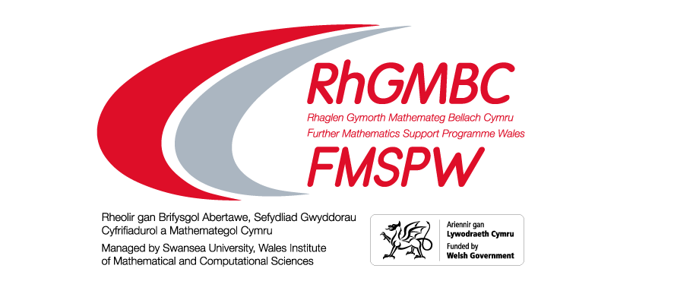 | Ffurflen Gais / Application Form  Mathemateg Ychwanegol – Adolygu Ar-lein  Additional Maths – Online Revision

Session 1: Sat 11th June – 10:00 to 12:00 - Revision of all key techniques.
Session 2: Monday 20th June – 16:30 to 18:00 - Practise paper walk through.
Sesiwn 1: Sadwrn 11 Mehefin – 10:00 i 12:00 - Adolygu'r holl dechnegau allweddol
Sesiwn 2: Llun 20 Mehefin – 16:30 i 18:00 - Mynd trwy bapurau ymarfer

Enw’r Ysgol / School Name: |  | Cyswllt Athro/ Teacher Contact:
Ebost Athro/ Teacher Email:

Cyfanswm y myfyrwyr a restrir isod
Total Numbers for students listed below
Bachgen Male
Merch Female
Anneuaidd Non Binary
Faint o’r disgyblion sydd o gefndir ethnig lleiafrifol?
How many of the pupils are from an ethnic minority background?
Faint o'r myfyrwyr sy'n derbyn lwfans Prydau Ysgol/Cynhaliaeth Addysg am ddim?
How many students are in receipt of free school Meals/Education Maintenance allowance?
Faint sydd mewn gofal neu'n gadael gofal?
How many are in care or a care leaver?
Faint o'r myfyrwyr sydd ag Anghenion Dysgu Ychwanegol?
How many of the students have Additional Learning Needs?

Enw’r Myfyriwr  Name of Student | Cyfeiriad Ebost Myfyriwr  Student Email Address | Sesiwn 1  Saesneg  Session 1  English | Sesiwn 1  Cymraeg  Session 1 Welsh | Sesiwn 2 Seasneg  Session 2 English | Sesiwn 2 Cymraeg  Session 2 Welsh

Nid oes uchafswm ond byddem yn eich annog i gael y myfyrwyr i lenwi’r adborth electronig
There is no maximum number but we would encourage you to get the students to submit the electronic feedback.

