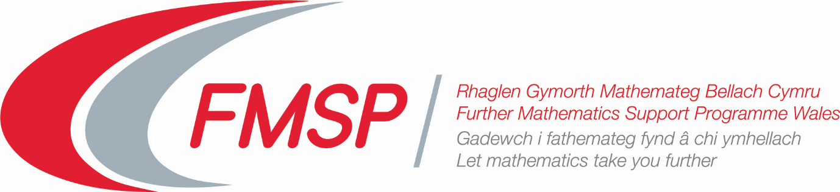

Introduction to the online Professional Learning Course for Further Maths Unit 3 (Mechanics).

The course is split into three periods of study, each of two or three weeks, that will enable participants to study the content of the module and encounter possible teaching approaches in the comfort of their homes. This will be backed up by both the opportunity to email the tutor during the study period and a zoom meeting with the tutor at the end of each study period in which some exam style questions will be considered.

Study Period 1 | Work, Power, Energy and Elastic Strings | - Mathematical Modelling  - Work and Energy  - Power  - Springs and Strings
Study Period 2 | Impulse, Momentum and Vector Methods | - Impulse and Momentum  - Coefficient of Restitution  - Vector Calculus  - Vectors in Mechanics
Study Period 3 | Circular Motion | - Horizontal Circular Motion with constant angular speed  - Vertical Circular Motion  - Modelling examples

The resources for each topic will be placed in a folder on Microsoft Teams.

The resources for each session include
- The flipped classroom videos which, although initially prepared for use by A-level students, will give a valuable overview of the concepts to be encountered.
- PowerPoints which develop the major concepts and illustrate them with fully worked solutions to examples.
- Exercises (with outline solutions) : participants are encouraged to work through at least some of these!
- Where appropriate, geogebra files illustrating the concepts or providing animations of the physical situations.
- A final PowerPoint containing the questions that we will be considered during the zoom meeting: participants are encouraged to have a go at as many as possible of these before the session so that solution methods and any problems encountered can be discussed during the zoom meeting.

An extract from the study material from the first session can be found ……….

